SPRINT – 4

|  |  |
| --- | --- |
| **DATE** | **14 NOVEMBER 2022** |
| **TEAM ID** | **PNT2022TMID33576** |
| **PROJECT NAME** | **SMART WASTE MANAGEMENT FOR METROPOLITAN CITIES-IOT** |

NODE RED & MIT APP INVENTOR OUTPUT :

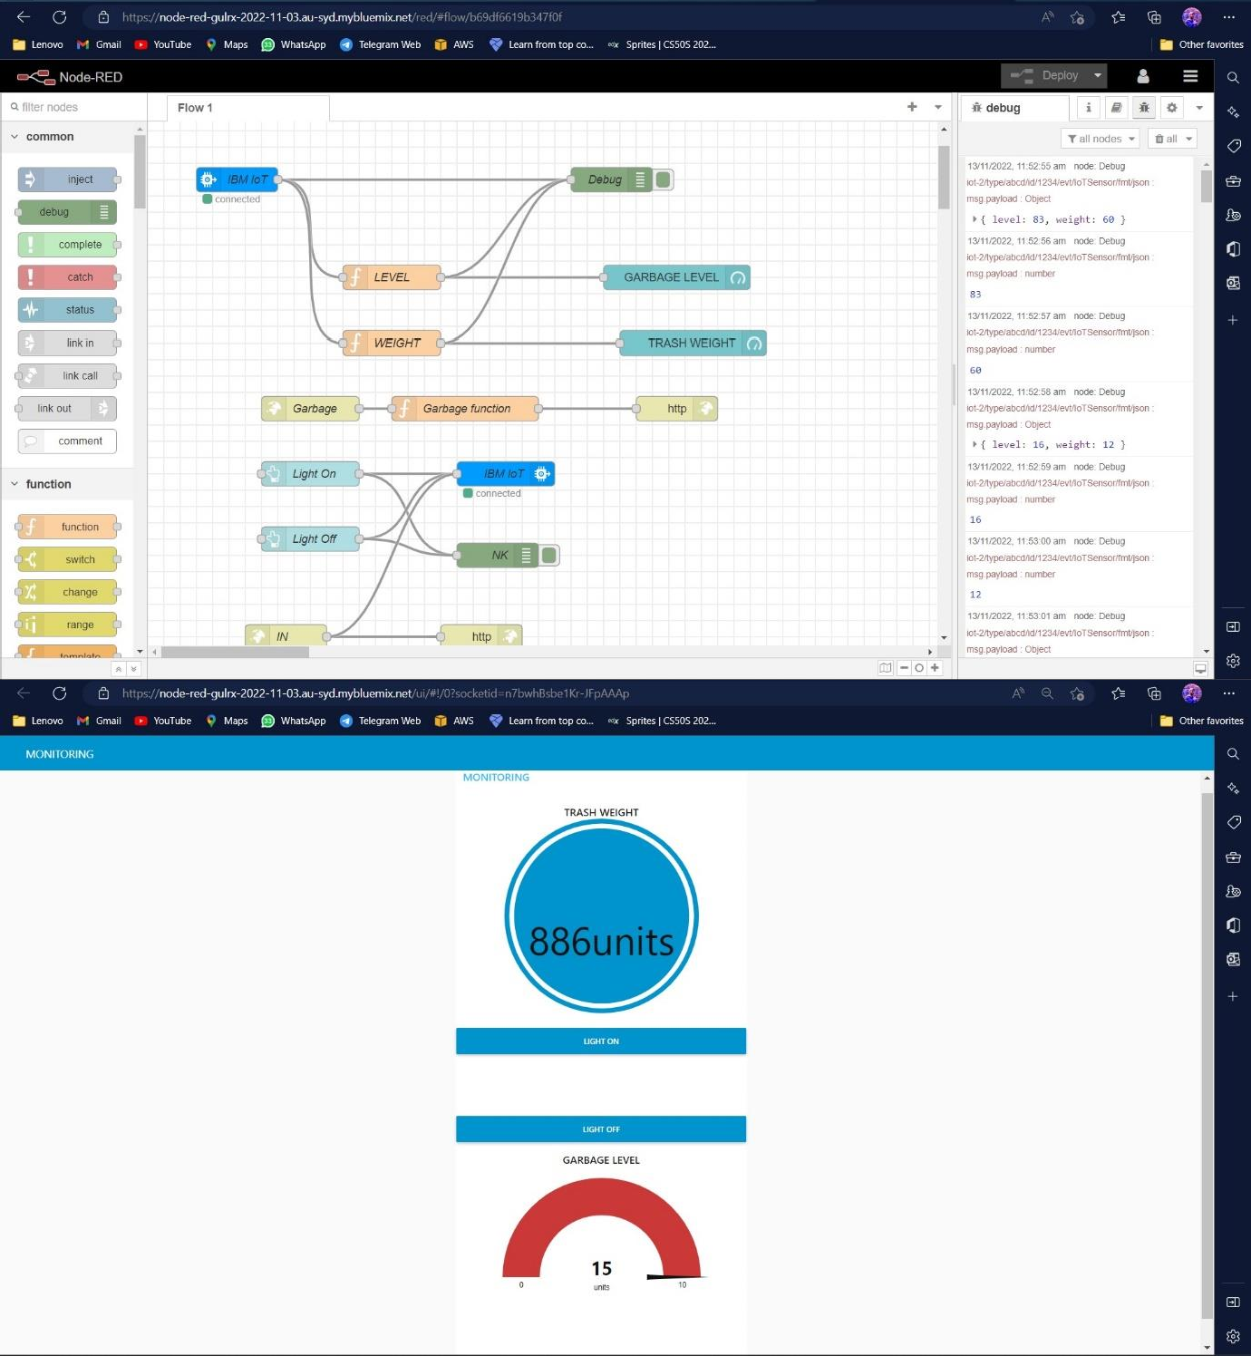

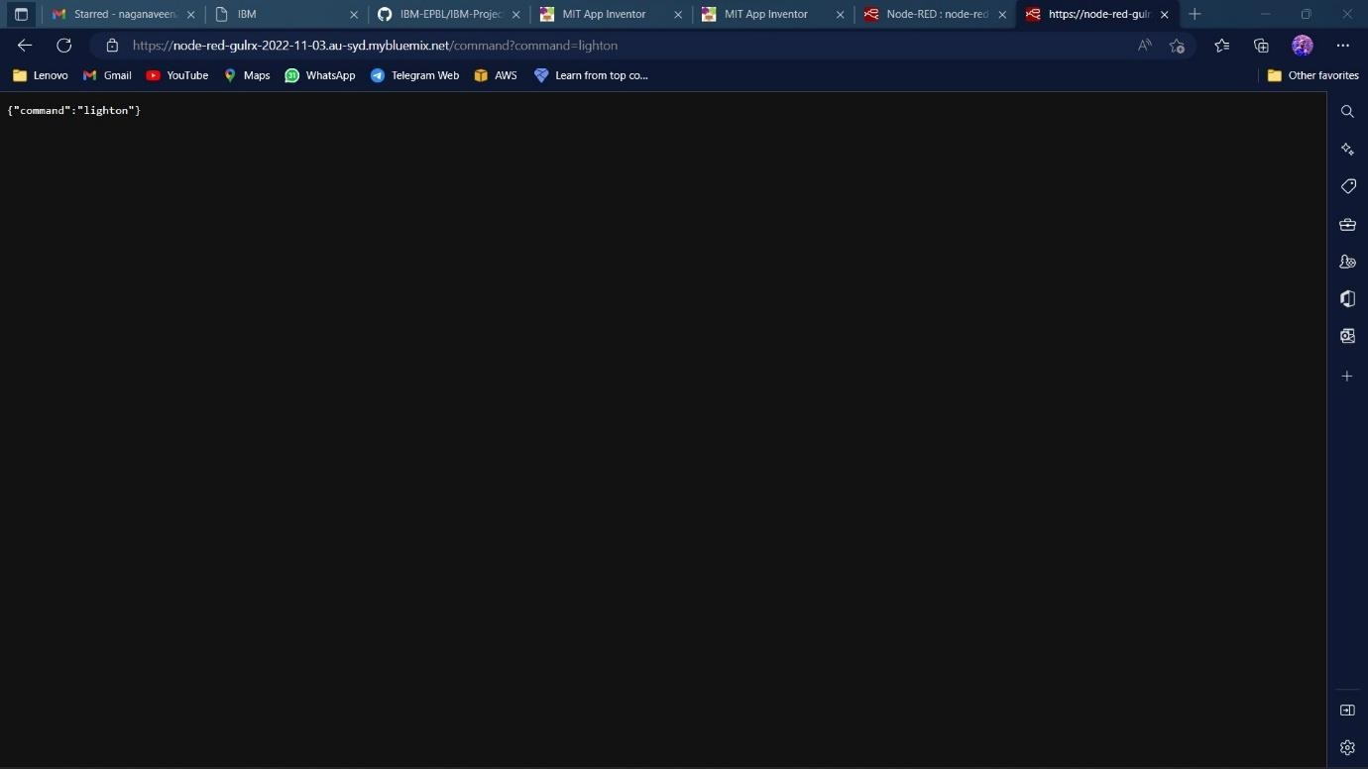

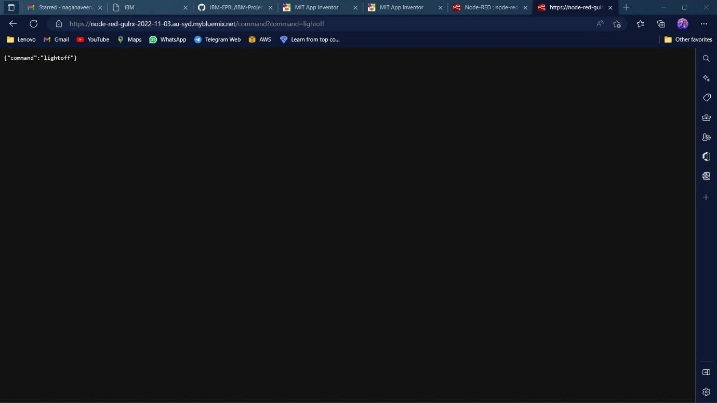

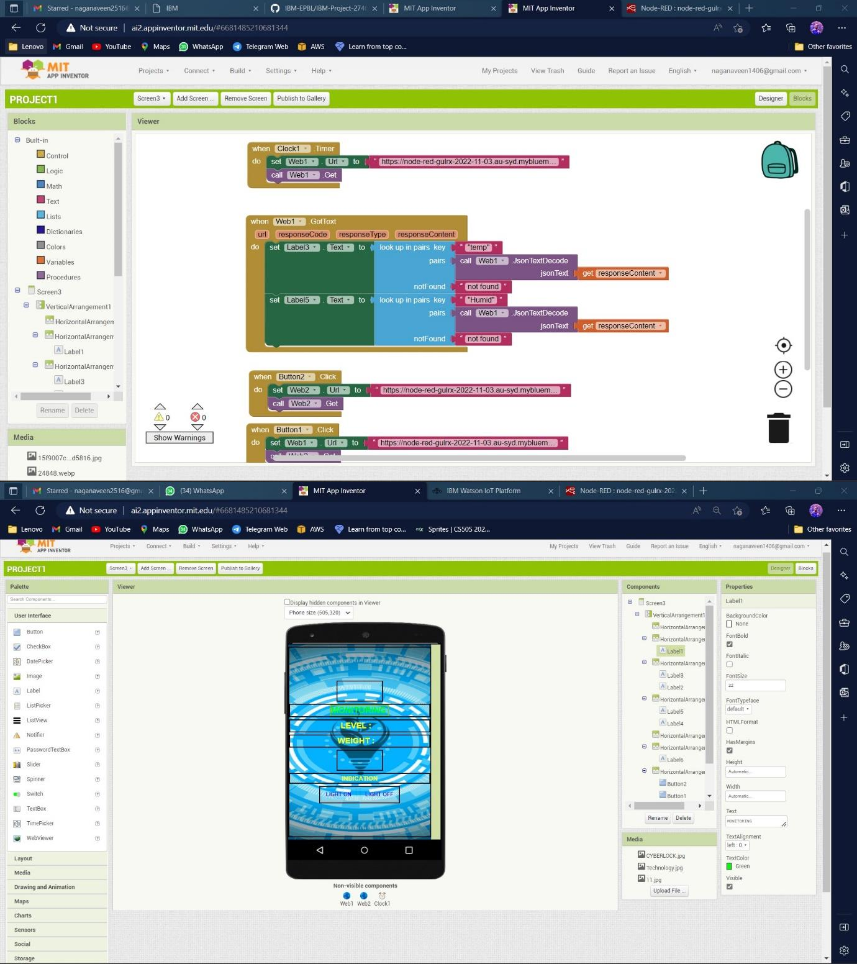

OUTPUT BY PHONE :

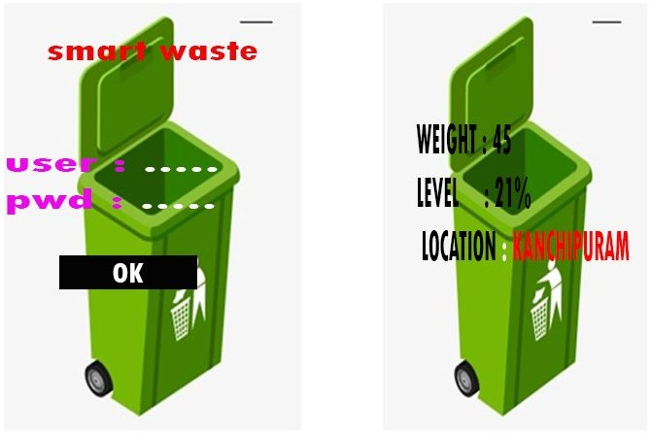

SCREEN 1 SCREEN 2